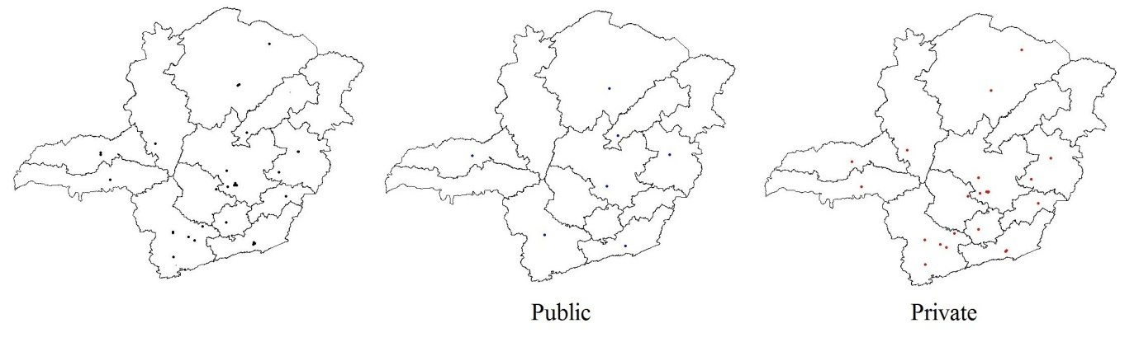FIGURE 2. Distribution of dentistry schools in Minas Gerais state, Brasil, 2016.

