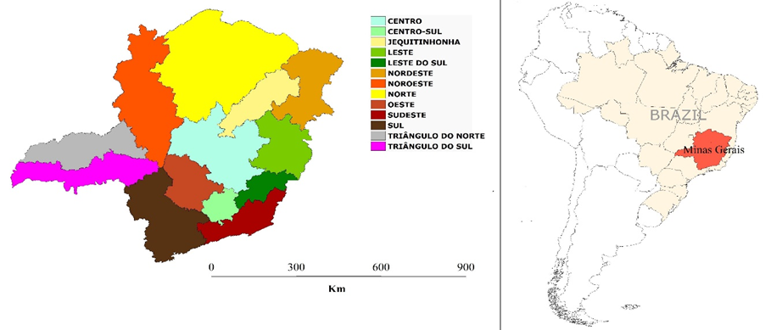
FIGURE 1. Geographical location of Minas Gerais state and regional division, Minas Gerais, Brazil, in 2016.

